GUÍA EVALUADA DE RESUMEN UNIDAD 0
Guía n° 1 STRANGE FOOD
INGLES

Nombre: |  |  |  | Curso: | IIM A B C | Fecha
Puntaje Evaluación |  | 86 | Puntaje de corte (60%): |  | 40
Puntaje obtenido: |  |  | Calificación:

-Instructions;
LEE EL TEXTO Most Bizarre Foods Y CONTESTA LAS PREGUNTAS:
ENVIAR GUIA DESARROLLADA ONLINE HASTA EL DIA MARTES 24 DE MARZO AL CORREO paula.aracena@elar.cl nota sumativa

Si quieres conocerlas puedes ver en youtube;
Sake wine nhttps://www.youtube.com/watch?v=SlSw1LB6crY
Kimchi https://www.youtube.com/watch?v=UpaXJDp_0jo
Kopi https://www.youtube.com/watch?v=U8jHaCVFHvU
Live octopus https://www.youtube.com/watch?v=v5xuS03-s_4
Casu Marzu, Sardinia https://www.youtube.com/watch?v=GfzPzPkSX3s&t=459s

Balut, Philippines https://www.youtube.com/watch?v=-JahpC-8uZ4&t=43s

Fried Tarantulas, Cambodia https://www.youtube.com/watch?v=GZkhpRfqsI0
Birds Nest Soup, China https://www.youtube.com/watch?v=t_DZHX4UEQM&t=799s

Se recomienda dictionary
https://www.ldoceonline.com/es-LA/

Objetivos:
OA9
Demostrar comprensión de ideas generales e información explícita en textos adaptados y auténticos simples, en formato impreso o digital, acerca de temas variados (como temas de interés de los y las estudiantes, temas de otras asignaturas, del contexto inmediato, de actualidad e interés global, de otras culturas y algunos temas menos conocidos) y que contienen las funciones del año
Contenidos;
Food around the world

Read the text and answer the questions

Most Bizarre Foods: 8 Dishes you have to see to Believe

Snake Wine, Vietnam
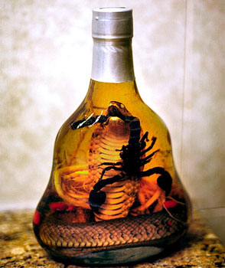 | Fancy some wine with a difference? A bouquet of snake with some snake blood notes perhaps? Snake wine is a bottle of rice wine with a venomous snake inside and has ‘medicinal purposes’, but is probably more useful for display purposes than to drink. The snake is left to steep in the rice wine for many months to let the poison dissolve in the wine. The ethanol makes the venom inactive so it is not dangerous, and snake wine supposedly has many health benefits. It has a slightly pink color like a nice rose because of the snake blood in there.

Kimchi, Korea
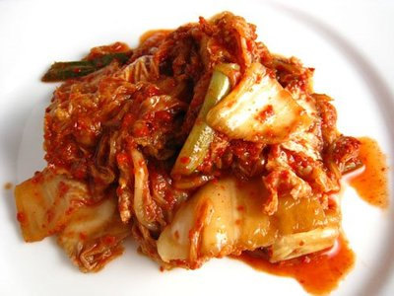 | This spicy garnish is a traditional Korean favorite. You may be familiar with the popular side dish. You may even be wondering why this dish made the top ten most bizarre Asian foods. What you don't know about kimchi is that the spicy cabbage you're eating carries with it a unique zesty quality due in part to long periods of fermentation. That's right, kimchi is rotten cabbage. And any rotting dish that has managed to become as popular as kimchi makes our list.

Kopi Luwak, Indonesia
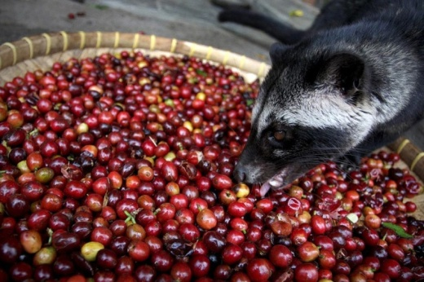 | Kopi Luwak is the rarest, most expensive gourmet coffee in the world. Sounds divine right? It’s actually made from the excrements of an Indonesian cat-like creature called the Luwak. The Luwak eats only the ripest coffee cherries but its stomach can’t digest beans inside them, so they come out whole. The coffee that results from this process is said to be like no other, and the stomach acids and enzymes that perform the fermentation of the beans give the coffee a special aroma. Price? US$120 to $300 per pound.

Live Octopus, Korea
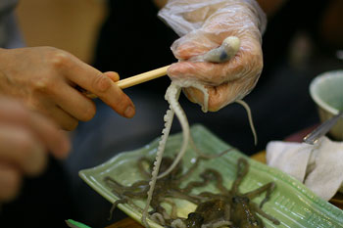 | In Korea Sannakji is a raw dish consisting of live octopus. The octopus is cut into pieces whilst still alive, lightly seasoned with sesame oil and served immediately whilst the tentacles can still be seen squirming on the plate. Eating live octopus is a challenge not only mentally trying to get your head round eating something that’s still alive, but physically, as the tentacles stick to any surface they touch (the suction cups stick to your mouth or throat)

Casu Marzu, Sardinia (Italy)
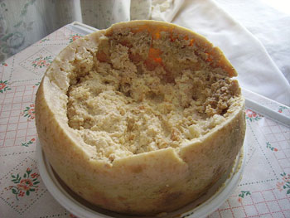 | This Sardinian cheese is a cheese with a difference; it’s riddled with insect larvae. “Casu Marzu” means ‘rotten cheese’ and is most commonly referred to as “maggot cheese”. The sheep’s milk cheese is basically Pecorino, which has had the larvae of the cheese fly on it. Fermentation occurs as the larvae digest the cheese fats, and the texture becomes very soft with some liquid seeping out. The cheese has to be eaten when the maggots are still alive because when they are dead it is considered to be toxic.

Balut, Philippines
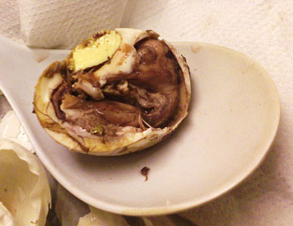 | A bit like with a Kinder Surprise, you certainly will be surprised to open these eggs, though not in the same pleasant way as finding a toy inside. You get to eat your chicken and your egg at the same time with Balut. In other words, chicken’s fetus!. These eggs are cooked when the fetus is anywhere from 17 days to 21 days depending on your preference, although when the egg is older the fetus begins to have a beak, claws, bones and feathers.

Fried Tarantulas, Cambodia
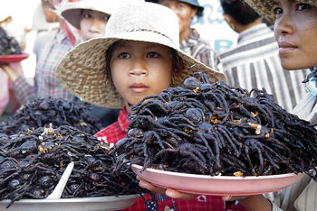 | if you suffer from arachnophobia you probably don’t want to try eating these eight legged monsters. They’re not tiny little house spiders, they’re great big tarantulas and you can buy them in the streets of Skuon, Cambodia. They’re fried whole – legs, fangs and all. They cost only a few cents and supposedly taste delicious, as they are best plucked straight from the burrow and pan fried with a bit of garlic and salt. They’re supposed to taste a bit like crickets or scrawny chickens and are crispy on the outside with a gooey body on the inside.

Birds Nest Soup, China
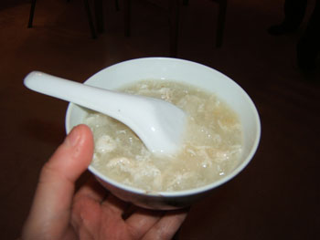 | You wouldn’t necessarily think a birds nest would be edible, but the Chinese use Swifts’ nests to make this soup, known as the ‘Caviar of the East’. Right now you’re probably imagining a nest made out of twigs and leaves, but Swiftlets make their nests predominantly out of saliva. It’s something in the saliva of the bird that makes it have this unique gelatinous, rubbery texture and it’s one of the most expensive animal products consumed by humans. A bowl of soup can cost around US$30 to $100 per bowl, whilst a kilo of nest can cost between US$2,000 and $10,000.

Cooking Vocabulary (70 points}
Kitchen equipment | Ways of cooking food | Other things you do to  Food
cooking chopsticks________________________  dishwasher_______________________  measuring cup____________________  cooker/ stove_____________________  potato peeler_____________________  bottle opener_____________________  spatula, rolling pin_________________  can opener______________________  knife______________________  sieve, mixing bowl___________________________  freezer____________________  kitchen roll_________________  fish slice_______________________  spoon_________________  cling film______________________  kitchen knife_____________________  measuring spoon___________________  oven, microwave__________________  fridge__________________  aluminum foil____________________  wooden spoon__________________  chopping board__________________  colander_________________  frying pan___________________  saucepan, apron___________________  serving spoon_____________________  oven glove, tongs_____________________  pepper grinder___________________  coffee grinder______________________ | Grill_________________  Bake________________  Roast_______________  Fry__________________  Boil___________________  Steam__________________  Toast_________________  Stew___________________ | Mix____________________  Squeeze________________  Slice____________________  Separate________________  Chop________________  Grind__________________  Whisk___________________  Peel_____________________  Grate___________________  Spread___________________  Mash______________________  Wash____________________  Pickle____________________  stir fry____________________  crush______________________  press______________________  smoke____________________  wrap___________________  roll___________________  stir_____________________
 | Food Adjectives
Baked_____________
boiled__________
blended__________
caked__________
crunchy__________
creamy__________
covered__________
exquisite__________
exotic__________
fried__________
greasy__________
mouth-watering__________
rancid__________
salty__________
Raw_______________.
Read the text and fill the form:12 points
Dish name | Ingredients | Country

Answer the questions:4 points

1.-What do you think is the strangest of these dishes?

______________________________________________

2.-Do you know any other strange dish?

________________________________________________

